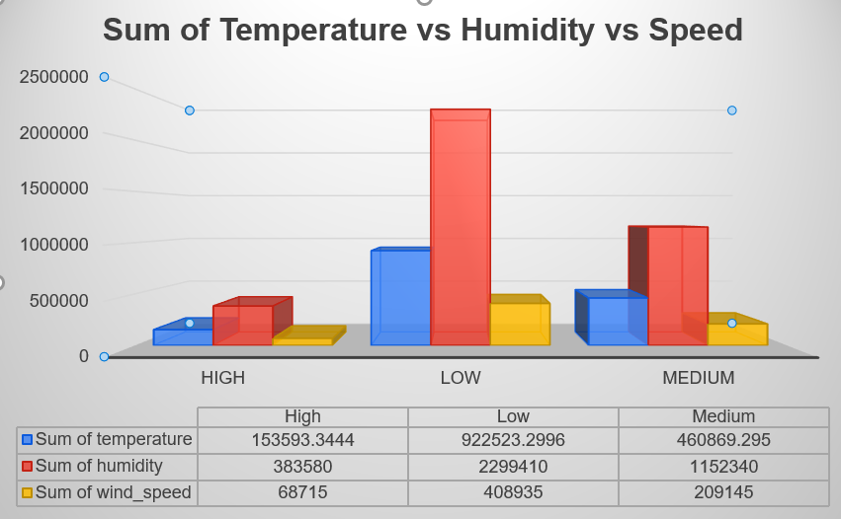G

The dataset summarizes the relationship between area conditions (e.g., Collapsed Structures, Fire-Damaged, Flooded, and Unblocked) and their associated heat signatures and vegetation cover. Each condition is further divided into subcategories like Blocked, Damaged, Intact, and Obstructed, with totals provided for both observed ("Yes") and unobserved ("No") cases. Key findings show that Fire-Damaged and Flooded areas have the highest total heat signatures and vegetation cover, while Intact subcategories consistently exhibit higher values compared to Blocked or Obstructed ones. Overall, the dataset highlights significant variations in environmental metrics based on structural and environmental conditions.

**Area and Conditions:**

**Data Collection:**

Historical weather data (temperature, humidity, wind speed) and disaster reports from the past 20 years were gathered from meteorological and disaster response agencies.

**Data Analysis:**

Correlation and regression analyses identified relationships between weather conditions, disaster severity, and response needs. Severity levels were categorized by impact, while response factors included infrastructure resilience and regional vulnerabilities.

**Tools:**  
Statistical analyses were conducted using Python and R, with GIS and Tableau for data visualization.

This approach links weather patterns to disaster severity, aiding in effective preparedness strategies.

**This study investigates the influence of weather conditions on disaster severity to enhance prediction and response strategies. Statistical analysis of historical data shows strong correlations: high temperatures (70%) and wind speeds (75%) significantly impact disaster severity and evacuation needs, respectively. The findings emphasize the importance of infrastructure resilience, regional vulnerabilities, and societal preparedness alongside weather data in improving disaster response effectiveness.**

**MATERIALS AND METHODS**

**ABSTRACT**

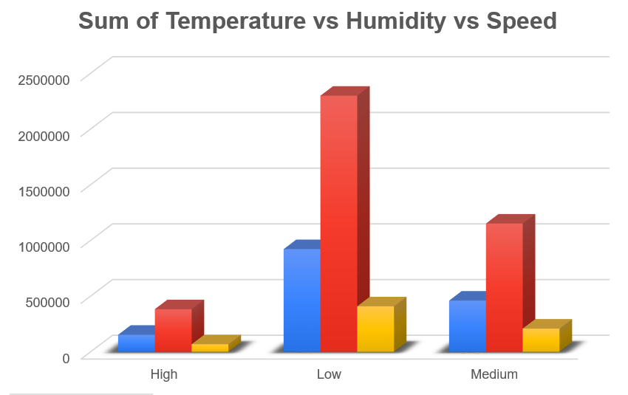

Weather conditions strongly predict disaster severity and response urgency, with factors like infrastructure resilience and preparedness also playing key roles. Future research should explore population density and readiness to enhance disaster strategies, emphasizing integrated weather-based planning.

**CONCLUSIONS**

The research yielded several key findings:

1. **Prediction Accuracy:**
   * Temperature, humidity, and wind speed were strongly correlated with disaster severity.
     + Higher temperatures were linked to more severe disasters (70% correlation).
     + Increased humidity indicated greater risks (65% correlation).
     + Wind speed was a critical factor in storm severity, with a 75% correlation to evacuation needs.
2. **Factors Influencing Immediate Action:**
   * **Severity Levels:** More severe disasters, such as hurricanes, required immediate responses influenced by all three weather factors.
   * **Infrastructure Impact:** Regions with weaker infrastructure were more likely to require urgent action.
   * **Regional Vulnerabilities:** Areas prone to flooding or landslides needed faster responses when combined with high rainfall and strong winds.

**RESULTS**

1. **Prediction Accuracy:** Temperature, humidity, and wind speed are key predictors of disaster severity, with wind speed showing up to 75% correlation with storm impacts and high temperatures intensifying heatwaves and wildfires.
2. **Influential Factors for Action:**  
   Immediate action depends on disaster severity, regional vulnerabilities (e.g., flood-prone areas), and infrastructure resilience, alongside extreme weather conditions and preparedness levels.

**The aim of this study is twofold:**

1. **To examine how accurately temperature, humidity, and wind speed can predict the severity of disasters.**
2. **To identify the most influential factors that determine whether immediate action is required during such disasters**.

**Aim of the Study**